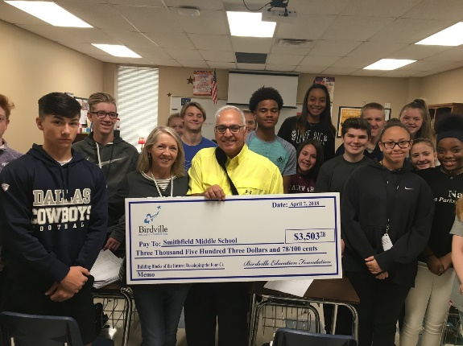
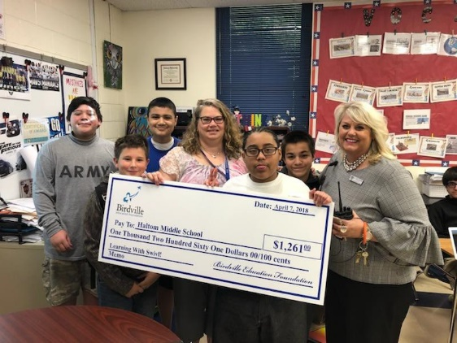
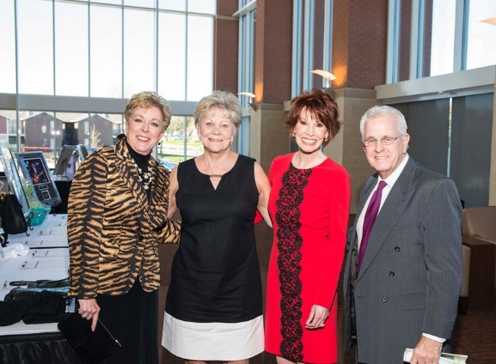

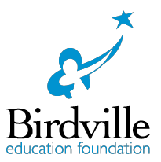
INTRODUCTION

The mission of the Birdville Education Foundation is to enhance innovative learning and support the educational excellence of Birdville ISD.

The Foundation, a 501(c)3 nonprofit organization, supportive of, yet separate from Birdville ISD, is governed by a volunteer board of corporate, community, and educational leaders dedicated to this mission.

Since 1996, and thanks to the generosity of donors like you, the Birdville Education Foundation has raised and awarded more than $2,014,350 to our deserving Birdville ISD classrooms and campuses, funding needs our educators identify – everything from books to robotics – touching the lives and impacting teachers, students and families throughout the district.

The need for our community’s support of our school district’s commitment to our students is greater than ever. Increased enrollment, ever-changing demographics and fast- paced curriculum and technology changes cause an increased need for the annual investments you help us make through the classroom teacher grants.

We all want what is best for Birdville. Jumpstart your personal and corporate commitment to our educators and students today. Your early pledge of support to our Best for Birdville campaign 2022-2023 will be recognized year-round and beyond in all print and electronic collateral, and at Foundation and district events.

Please email us at bisdef@birdvilleschools.net, or visit our webpage at www.birdvilleeducationfoundation.com to learn more about how to support the mission of the Birdville Education Foundation.

ANNUAL CAMPAIGN 2022-2023

2022-2023 BOARD OF DIRECTORS

OFFICERS

Martha Strain, President

Sharon Mylius, 1st Vice President

Doug Terry, Secretary

Taylor Coffman, Immediate Past President

Katie Bowman, BISD Associate
Superintendent for Finance

EX-OFFICIO

Dr. Gayle Stinson, Superintendent of Schools

Mark Thomas, Communications Officer

Kelvin Dilks, President Board of Trustees

Richard Davis, Vice President Board of Trustees

The mission of the Birdville Education Foundation is to enhance innovative learning and support the educational excellence of Birdville ISD.
The Foundation, established in 1996, is a 501 (c)3 nonprofit organization, led by a volunteer Board of Directors who have a sincere interest in the success of the students and staff at Birdville ISD.
DIRECTORS

Oscar Trevino, Mayor City of North Richland Hills
O. Trevino Construction

Tom Harris, Alliance Air/Aviation Services

Johnny McIntosh, North Hills Travel & Cruise

Rita Wright Oujesky, Raymond James

Howard Shotwell, R & D Associates, Inc.

Robert Hinkle, NTE Mobility Partners

Billy Parks, Crossmark Church

Michael Delgado, Delgado Orthodontics

Robert Copeland, O. Trevino Construction

Jimmy Grant, Grant Insurance

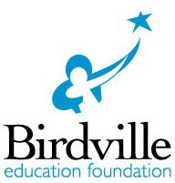
ANNUAL CAMPAIGN 2022-2023
BENEFITS TO YOUR INVESTMENT

YOUR TAX-DEDUCTIBLE LEAD GIFT WILL:

- Encourage others in our community to support our mission.

- Invest in the success of today’s teachers and students and in our workforce of tomorrow.

- Provide funding for the 2022-2023 campus and classroom Innovative Teaching Grants.

- Be recognized in print, electronic media, and events throughout the year as annual campaign supporter.

- Help us grow and improve to better support Birdville ISD’s commitment to excellence in education.

ADDITIONAL BENEFITS TO YOU INCLUDE: | Up to $250 | $250 | $500 | $1,000 | $2,500 | $5,000 | $10,000 | $20,000+
 | Friend | Partner | Advocate | Honor Roll | Scholar | Visionary | Hero | Champion
Satisfaction in making a difference! | ✓ | ✓ | ✓ | ✓ | ✓ | ✓ | ✓ | ✓
A named stadium chair at W.G. Thomas Coliseum |  | ✓ | ✓ | ✓ | ✓ | ✓ | ✓ | ✓
Invitation to Spring Best for Birdville Celebration | ✓ | ✓ | ✓ | ✓ | ✓ | ✓ | ✓ | ✓
Invitation to all Best for Birdville gatherings | ✓ | ✓ | ✓ | ✓ | ✓ | ✓ | ✓ | ✓
Sustainers (3 year pledges) - a named grant |  |  |  | ✓ | ✓ | ✓ | ✓ | ✓
Logo recognition throughout the year on print, electronic materials, and at events
 |  |  |  |  | ✓ | ✓ | ✓ | ✓
Name recognition throughout the year on print, electronic materials, and at events | ✓ | ✓ | ✓ | ✓

Please return the attached Intent to Give form with your donation or go online today!

Thank you for supporting the Birdville Education Foundation’s Mission!

Birdville Education Foundation | 6125 East Belknap | Haltom City, TX 76117 P: 817.547.5758 | E: bisdef@birdvilleschools.net

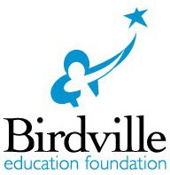
ANNUAL CAMPAIGN 2022-2023
INTENT TO GIVE FORM

□ YES, I/We will help the Birdville Education Foundation support excellence in education.
BEST for BIRDVILLE ANNUAL CAMPAIGN 2022-2023
□ $20,000 Champion □ $1,000 Honor Roll
□ $10,000 Hero □ $500 Advocate
□ $5,000 Visionary □ $250 Partner
□ $2,500 Scholar □ Up to $250 Friend $
□ Other $
All gifts through the Best for Birdville campaign go directly to classrooms and campuses through the Innovative Teacher Grants. You make a difference in the lives of our teachers and students. Thank you.
All gifts are tax deductible to the fullest extent allowed by law.
□ YES, I am a “Sustainer” of excellence in education for our district. My intent is to donate the amount checked above for school years: 2022-2023, 2023-2024, 2024-2025. (Sustainers at the Honor Roll level and above qualify for named grant.)

Name Company/Organization

Address
Phone ( )
City | ST | Zip
Fax ( )

Email
Donor name as you would like to see it in print
□ I am a BISD Alumni School(s) Graduation Year

□ My check is enclosed □ Invoice me in installments (within 3 months – Scholar level and above)
□ Please charge my □ Visa □ MasterCard □ American Express □ Discover
Name on Card Account No
Exp. Date CVV Code

□ I wish this gift to remain anonymous. □ My employer will match this donation. Please contact me.
□ Please contact me about including Birdville Education Foundation in my estate planning.
□ I request a meeting with an Education Foundation representative.
□ I decline all state benefits to my gift. I am just happy to make a difference.

This gift is given □ in Honor of □ in Memory of Name
Please notify
Name Address City|ST|Zip

Thank you for supporting the Birdville Education Foundation’s Mission!
Birdville Education Foundation | 6125 East Belknap | Haltom City, TX 76117 P: 817.547.5735 | E: bisdef@birdvilleschools.net

